Practical No: 5
Aim: Selenium Server (Grid) Configuration and Remote Execution Tool: Selenium Server (Grid) Install and configure Selenium Server in Hub-Node architecture. Execute a test script on multiple browsers using Remote WebDriver and compare cross-browser results.
Step I:
Requirements
Java JDK 11 or above
Selenium Server (latest JAR)
Chrome browser
Firefox browser
ChromeDriver and GeckoDriver (optional for older versions)
Eclipse/IntelliJ IDEA
Selenium Java library
DOWNLOAD JAVA JDK
Java JDK 11 or above
Step 1: Download Selenium Server
Download the Selenium Server JAR from the official Selenium website.
AFTER DOWNLOAD GO TO C DRIVE CREATE SELENIUM FOLDER IN C DRIVE Step 3: Configure Selenium Hub
OPEN COMMAND PROMPT
cd C:\selenium
C:\selenium>java -jar selenium-server-4.46.0.jar info
C:\selenium>java -jar selenium-server-4.46.0.jar hub
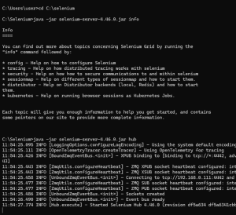
Search on chrome Started Selenium Hub
http://localhost:4444
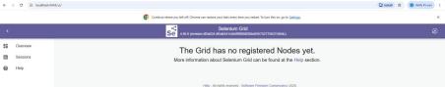Step 4: Configure Selenium Node
A Node is a machine/browser where tests are executed.
Start Chrome Node
Open another Command Prompt window.
Go to Selenium folder:
cd C:\Selenium
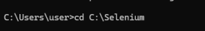
Start Node:
java -jar selenium-server-4.46.0.jar node
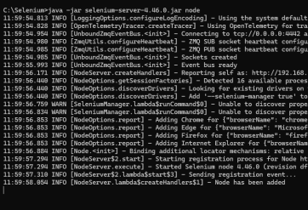
Step 5: Add Firefox Node (Optional)
If Firefox is installed:
Open another Command Prompt.
Run:java -jar selenium-server-4.46.0.jar node --browser firefox
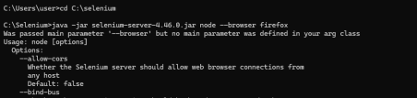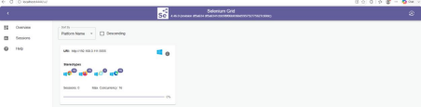
Step 7: Create Selenium Project
OPEN ECLIPS:FILE NEW JAVA PROJECT ADD PCKAGE CLASS FILE

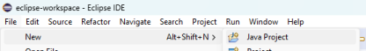Make package
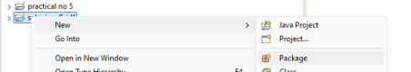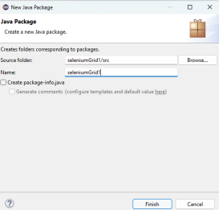
• Make two classes
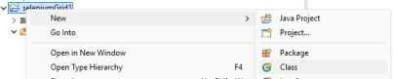
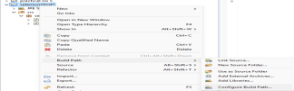
• Add External Jars
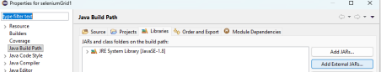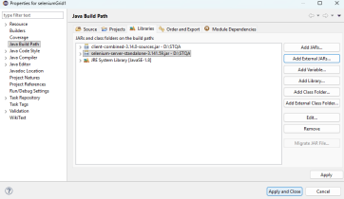Write this code in grid 1:
package seleniumGrid1;
import java.net.URL;
import org.openqa.selenium.WebDriver;
import org.openqa.selenium.chrome.ChromeOptions;
import org.openqa.selenium.remote.RemoteWebDriver;
public class grid1 {
public static void main(String[] args) throws Exception {
ChromeOptions options = new ChromeOptions();
WebDriver driver=new RemoteWebDriver(
new URL("http://localhost:4444"),
options);
driver.get("https://www.google.com");
System.out.println(driver.getTitle());
driver.quit();
}
}
The you run it will open google
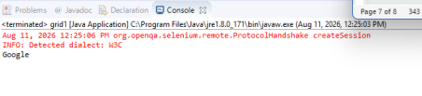code for grid 2:
package seleniumGrid1;
import java.net.URL;
import org.openqa.selenium.WebDriver;
import org.openqa.selenium.firefox.FirefoxOptions;
import org.openqa.selenium.remote.RemoteWebDriver;
public class grid2 {
public static void main(String[] args) {
try {
// Connect to Selenium Grid
URL gridURL = new URL("http://localhost:4444");
// Set Firefox browser options
FirefoxOptions options = new FirefoxOptions();
// Create RemoteWebDriver
WebDriver driver = new RemoteWebDriver(gridURL, options);
// Open website
driver.get("https://www.google.com");
// Print page title
System.out.println("Page Title: " + driver.getTitle());
// Maximize browser
driver.manage().window().maximize();
// Wait for 5 seconds
Thread.sleep(5000);
// Close browser
driver.quit();
} catch (Exception e) {
e.printStackTrace();
}
}
}

